DIS-US-Natick Manitou Grave stones-Natick Public Library-Final

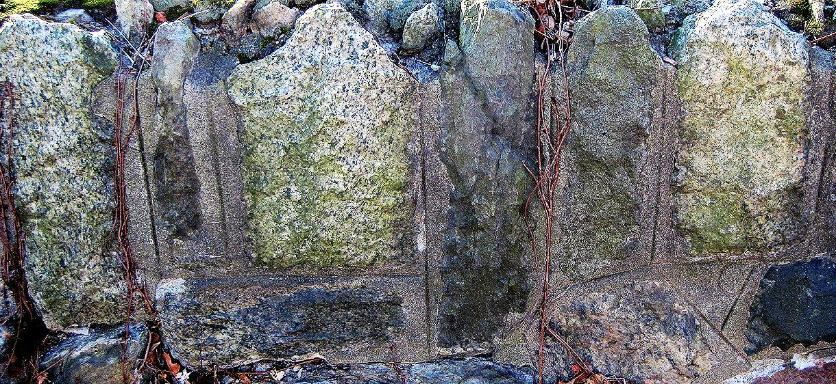

Manitou Gravesstones 1-6- Natick Public Library

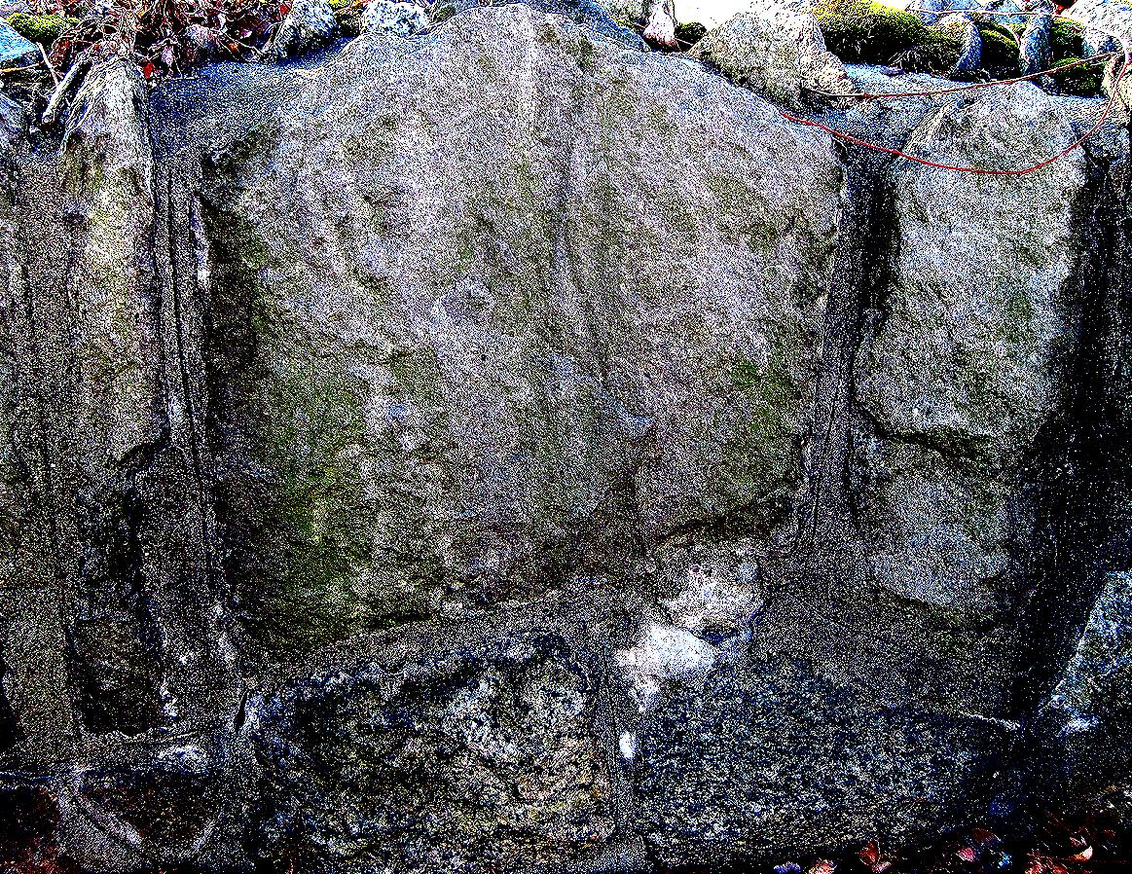

Manitou Gravesstones 7-9- Natick Public Library

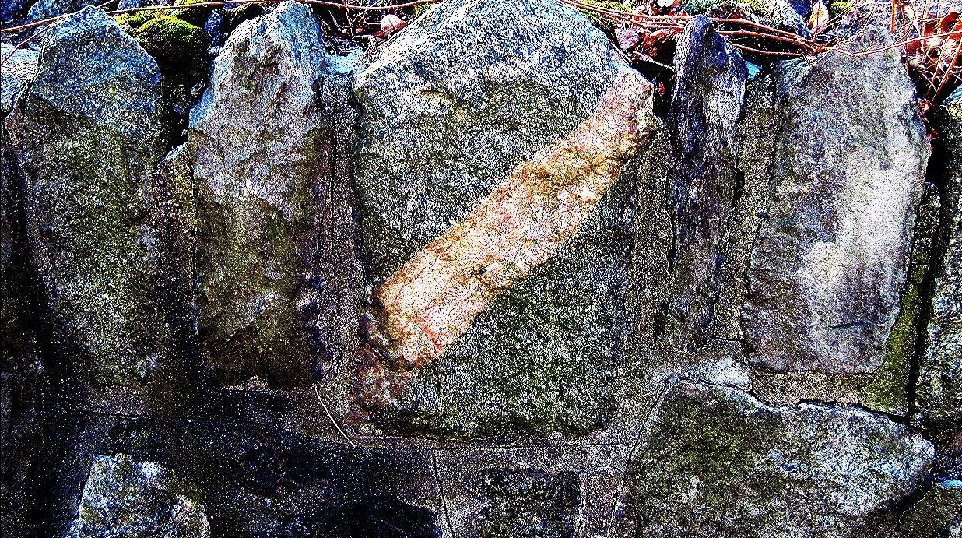

Manitou Gravesstones 10-14- Natick Public Library

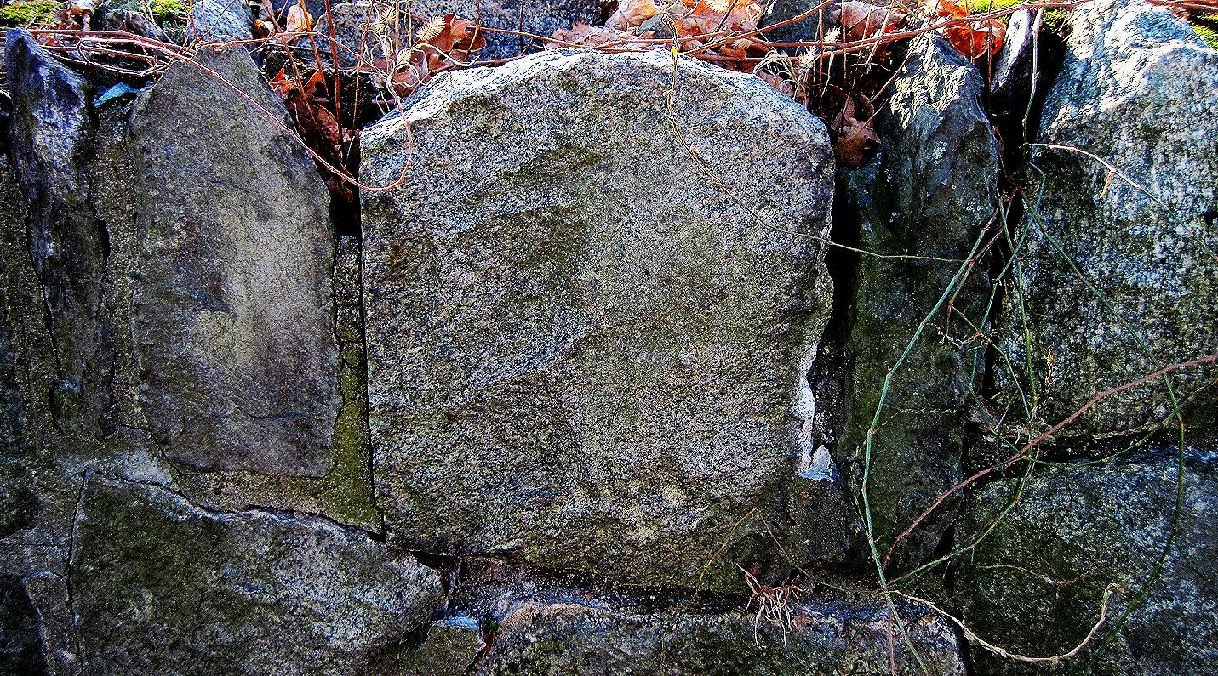

Manitou Gravesstones 15-19- Natick Public Library

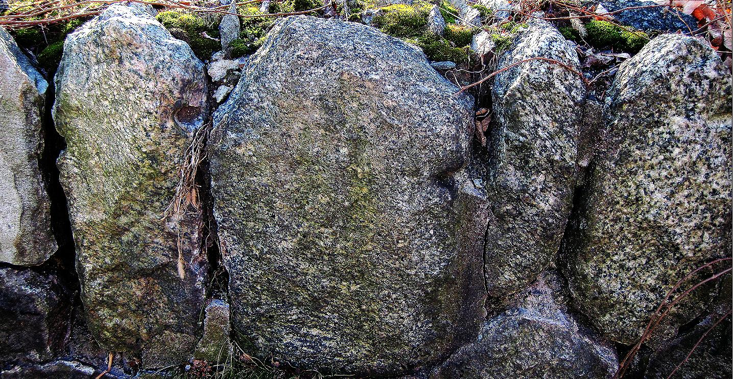

Manitou Gravesstones 20-24- Natick Public Library

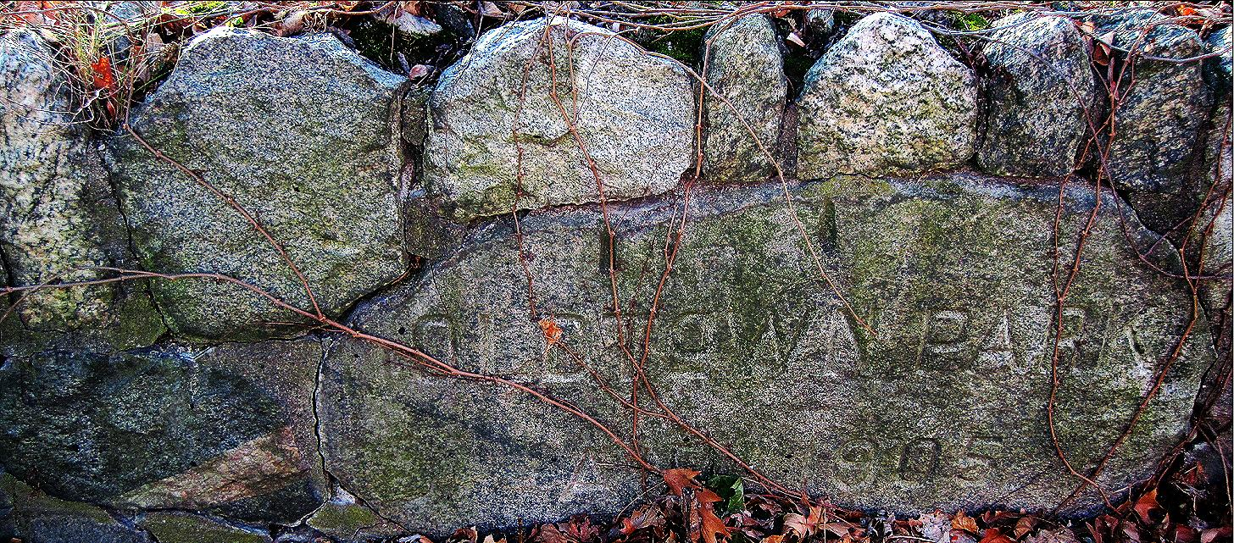

Manitou Gravesstones 25-31- Natick Public Library. "OLD TOWN PARK/ ANNO 1905"

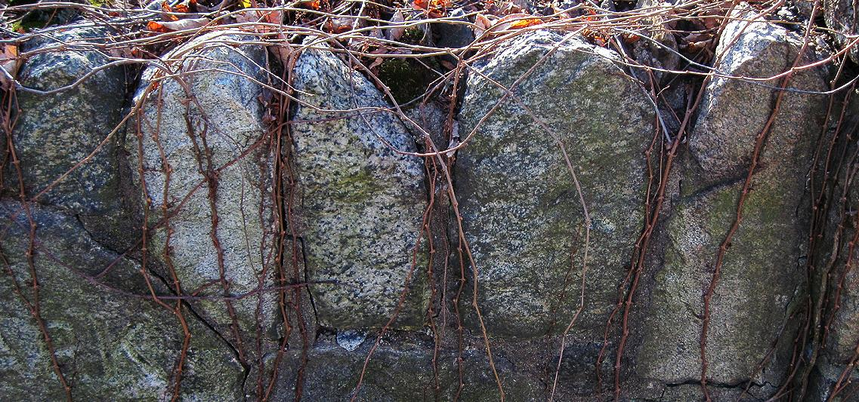

Manitou Gravesstones 31-34- Natick Public Library.

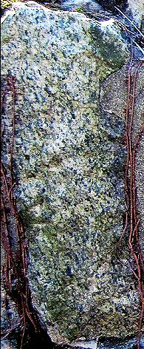 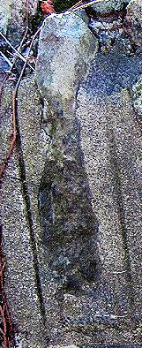

Manitou Gravestones 1-2

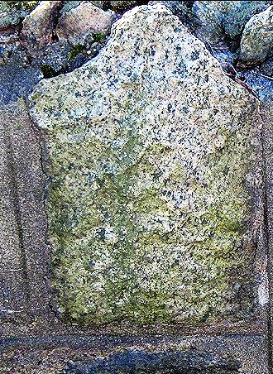

Manitou Gravestones 3-Classic Algonquian shape

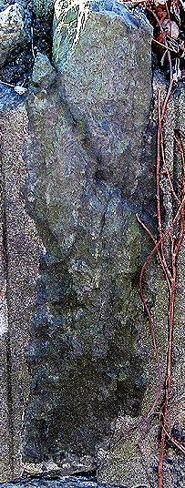

Manitou Gravestone3

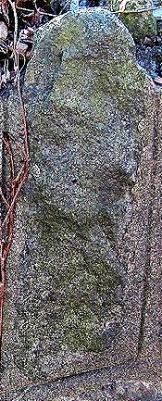 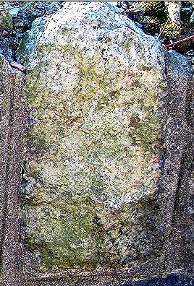

Manitou Gravestones 4-5-Classic Algonquian shape

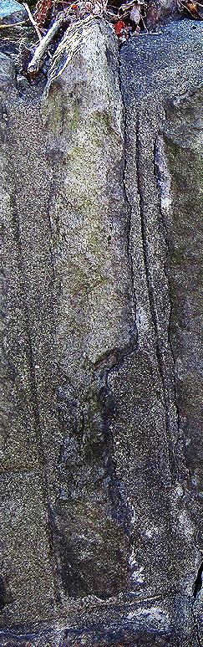

Manitou Gravestone 6

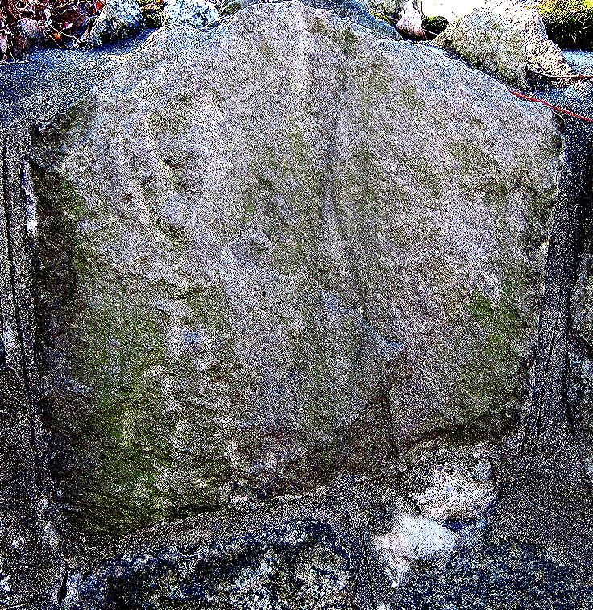

Manitou Gravestones 7-Classic Algonquian shape, with petroglyph lightly engraved

